# ***Hook Line and Slinger***

## Table of Contents

## Introduction

### Summary

A physics-based 2d platformer made for any age. Use your fishing rod to grapple around the map and find fish to defeat and cook.

### Inspirations

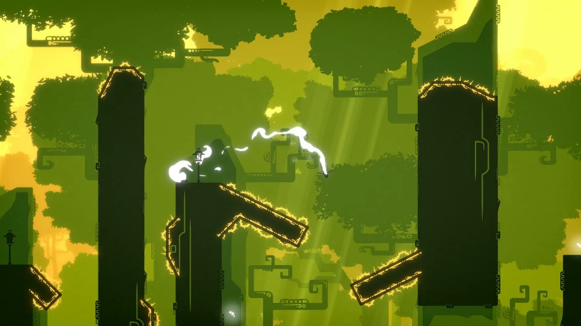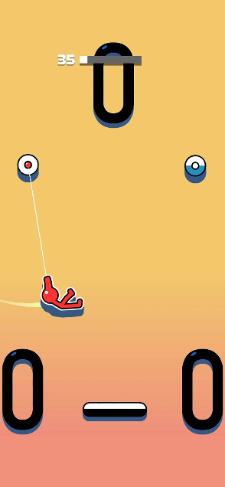My initial inspiration for the movement in the game is derived from *The King’s Bird* and the mobile game *Stickman Hook*. The movement of the former is smooth and enjoyable and has unique levels with extremely varying verticality in its obstacles and the latter is a good example of how I want the “grappling hook” mechanic to function in my game.

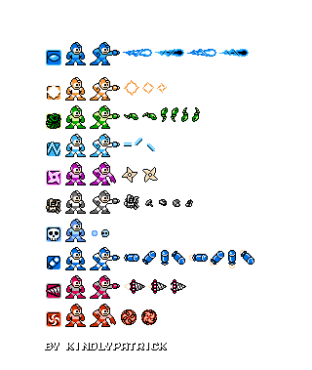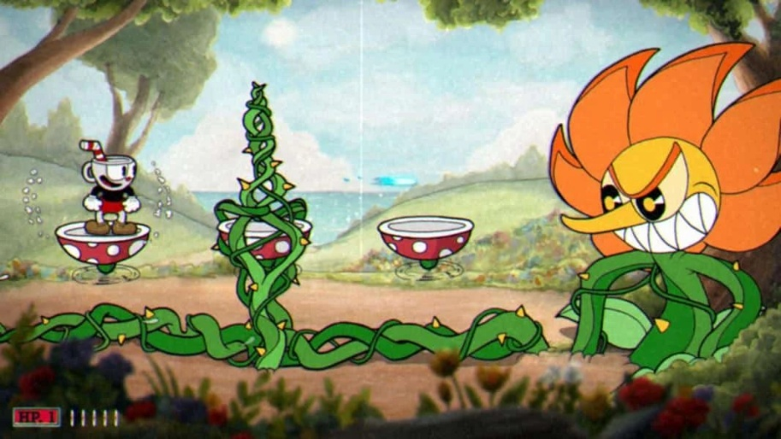For the main combat of the game, the character will fire projectiles at enemies to defeat them. For this ranged combat, I will be taking inspiration from *Cuphead* and the *Mega Man* franchise for their boss fights and weapon variety. The boss fights will be challenging and use the grappling hook in different ways and the character will have a plethora of bait to use against the enemies.

After figuring out how I want the movement to function, I realised that I wanted the character’s grappling hook to be a fishing rod. After reaching this conclusion, I want some kind of underwater environment that will be inspired by the game *Another Crab’s Treasure*. 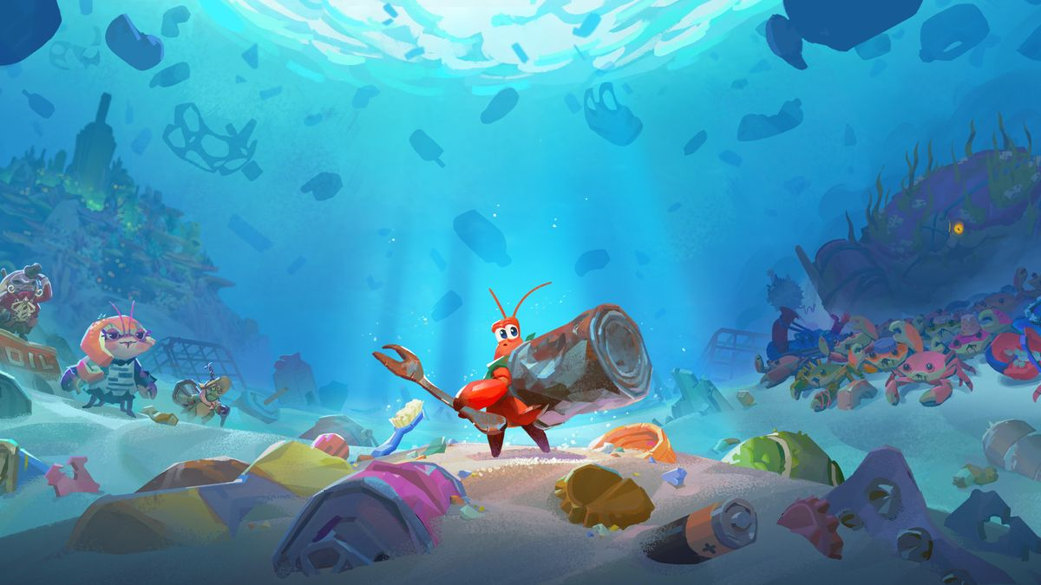

### Player Experience

The main aim for this game will be to make the movement as fun as possible for its players. Players should feel excited exploring the level, which will have fluctuating verticality, adding to the complexity and uniqueness of each level. If the player defeats all of the enemies throughout the area, it should take each player around half an hour to complete each area, depending on the player’s skill and understanding of grappling mechanics. During the boss fight at the end of each area, the players should feel a sense of challenge before feeling triumphant upon the boss’ defeat.

### Platform

If the game does get released for the general public to play, it will first and foremost be published on Steam, with the consoles following suit if it does well enough.

### Development Software

Hook Line and Sinker will be developed using the Unity Engine.

### Genre

A cartoon-style physics-based 2d platformer with a grappling hook, shooting mechanics, and an underwater theme.

### Target Audience

Hook Line and Slinger is targeted at people of all ages, for anyone who likes platformers, challenging games, and fish. For the players who like games like *Cuphead* and the *Metroid* series.

## Concept

### Core Loop

The player will go through each level, swinging from platform to platform, dispatching any fishy foes along the way using the projectiles in your arsenal. At the first, the player will start off with the default projectile, the trusty worm. The player can gain more kinds of bait, split between “live bait” and “artificial lures”, with different effects after defeating the corresponding type of fish.

After the player swings along the long and vertically varying path, they will encounter the boss of the level, a big fish. Each of these bosses will be enemies with a large health pool and attacks that require you to use the grappling hook in unique ways to avoid taking massive amounts of splash damage. Each boss will essentially be a skill check for the game and will each use a different part of the character’s movement to make the player master that aspect of the fishing rod before progressing.

After defeating each boss, the player will gain a new type of bait based on the boss, and will progress to the next area, which will contain enemies that will use attacks that the player will have (hopefully) learned how to counter from the boss. This process will be rinsed and repeated until the final boss, which will be a culmination of each boss the player has previously battled up to this point.

### Theme